VNSG 2461 Clinical Training III
Spring Dosage Calculation Assignment 1
Due January 16th at 5:00 pm

Directions: Round to the nearest tenth unless it specifies something else and no trailing zeroes; write your final answer in the space provided.

- The recommended dosage of Augmentin is 10 – 20 mg/kg/day divided into two equal doses. The Healthcare Provider (HCP) has prescribed Augmentin 250 mg IM BID for a child who weighs 25 kg. The Augmentin vial contains 125 mg of medication that must be reconstituted with 0.6 mL of diluent to yield 125 mg/1 mL.
  - What would the recommended minimum daily dosage this child could
receive?__250 mg__________________
  - What would the recommended maximum daily dosage this child could
receive?_500 mg___________________
  - Is the order within the recommended range? __yes_________
  - If so, compute the number of milliliters of Augmentin that should be
administered per dose. _250/125 = 2ml per dose___________________

- The pediatrician has prescribed Prednisone 2 mg/kg IV push every 12 hours. The child weighs 55 lb.
  - How many milligram should the child receive per dose? __50___________
  - How many milligram should the child receive per day? ___100__________

- The pediatrician prescribes Clindamycin 25 mg po every 6 hours for a child with a staph infection. The child weighs 44 lb. The drug reference recommends a dose of 12.5-50 mg/kg/24 hour.
  - Calculate the minimum recommended dose per day. ___250mg______________
  - Calculate the minimum recommended single dose. ___62.5mg_______________
  - Calculate the maximum recommended dose per day. ___1000mg______________
  - Calculate the maximum recommended single dose. ____250mg______________
  - Is this order within the recommended range for this child? __no___________

- A patient is receiving fluid from two IV lines. Line A is running at 25mL/hour and Line B is running at 90mL/hour.

What volume of fluid will the patient receive over 12 hours? ____1380ml_________________

- A patient is to receive 2550 mL of LR solution over 12 hour. How many mL/hr should the infusion pump be set for? (round to whole #)

____213_______________________

- The prescription for a patient reads 500 mL hypertonic saline solution to run over 5 hour. The IV is set to run at 100 mL/hr. With a drop factor of 15 gtt/mL, how many gtt/min should the patient receive? (round to whole #)

______25_____________________

- The Healthcare Provider prescribes 2000 mL of LR solution to infuse over 4 hours for a patient. The drop factor is 10 gtt/mL. What is the correct mL/hr and gtt/min? (round to whole #)

a._____500ml________________ b. ______83gtt_______________

- The Healthcare Provider has prescribed sliding scale insulin for the patient. You perform a chemstick at 0600 and the glucose level is 281. Based on the chart below, how much regular insulin will the patient receive? Circle your answer on the chart and mark the syringe below to indicate the correct dosage.
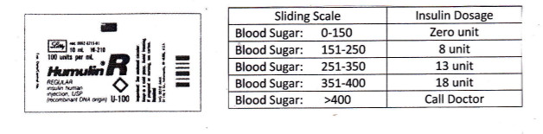
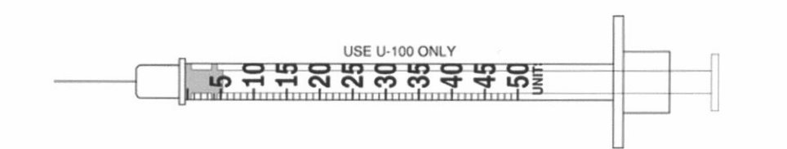

- A child weighs 32 lb. The prescription reads Cefaclor 217.5 mg po every 8 hours. Recommended dosage: 15 mg/kg/dose.
  - How many kg does the child weigh? (round to the tenth) _14.5____________
  - What is the recommended single dose for this child? __72.5___________
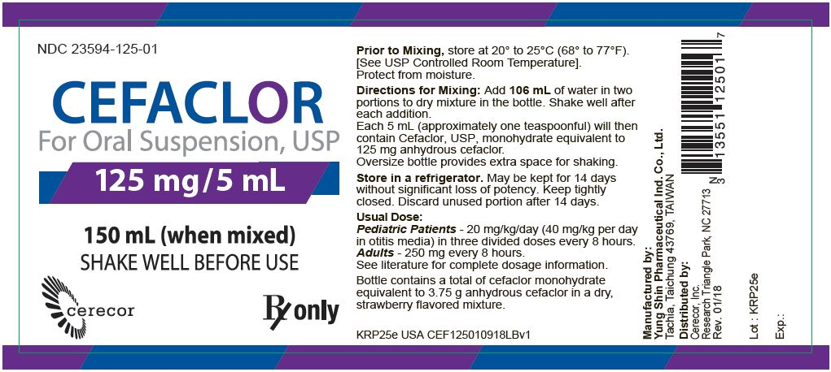

- Based on the prescribed dose and the medication label above how many mL of Cefaclor would you give per dose? (round to the tenth)

_______8.5________________

